TASKS ON EC2
Launch one EC2 using Amazon Linux 2 image and add a script in user data to install Apache
Steps to be followed to complete the task
Step 1: sign in to your aws account and select ec2 instance option
Step 2: then select launch instance option and select the AMI as amazon linux and select instance type & create or select security key
Step 3: select default firewall settings then select advanced details
Step 4: then write a script to install apache (httpd)
In my case using exit codes as well
#!/bin/bash
#script for installing apache
# We verify the exit status ($?) to ensure the command succeeded
sudo yum update -y
if [ $? -eq 0 ]; then
echo "updated successfully"
else
echo "update failed"
exit 1
fi
sudo yum install httpd -y
echo "installed apache"
sudo systemctl start httpd
if systemctl is-active --quiet httpd; then
echo " apache server started sucessfully"
else
echo "failed to start the service"
exit 1
fi
systemctl enable httpd
echo "sym link and enabled the service"
systemctl status httpd
echo "service has been started and working"
Then launch the instance
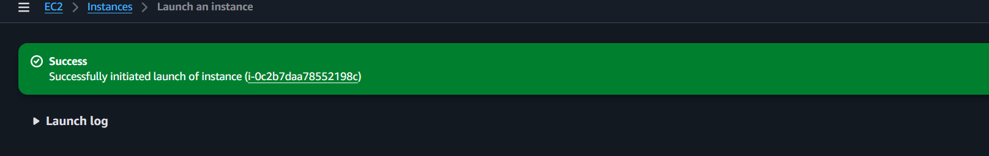
Step 5: Connect with your git bash using public ip and pem key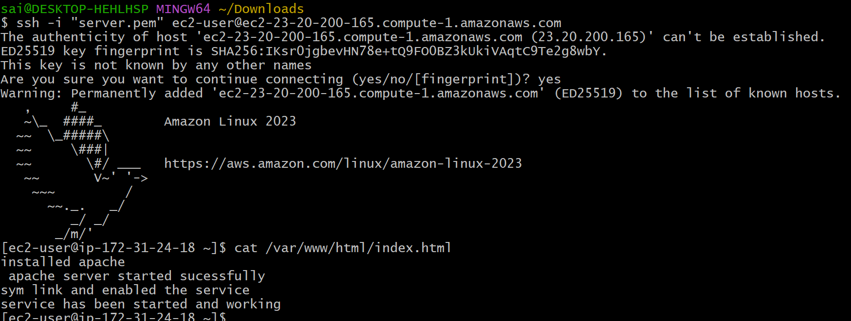
Step 6: check using public ip in website whether its working or not
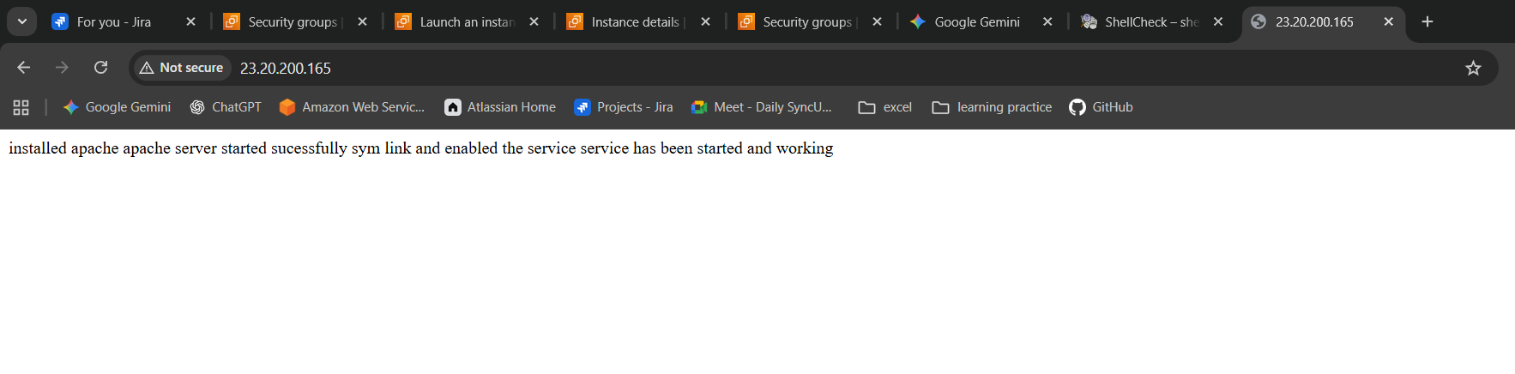

- Take a snapshot of the instance created in Task 1.
We are taking a snapshot of instance for case of backup all our instance data will be there in snap shot
Step 1: go to actions tab and select image and templates
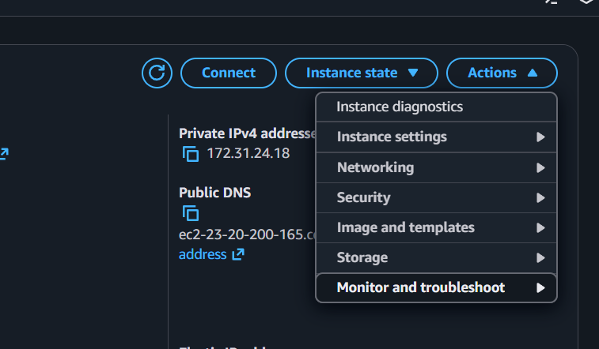

Step 2: select create image option to proceed
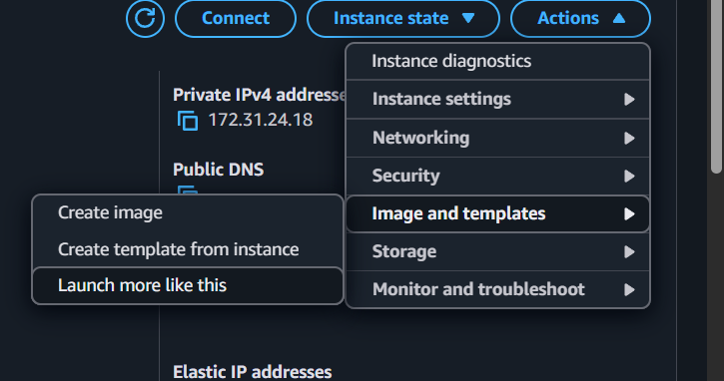
Step 3: enter the name and description as per your requirement
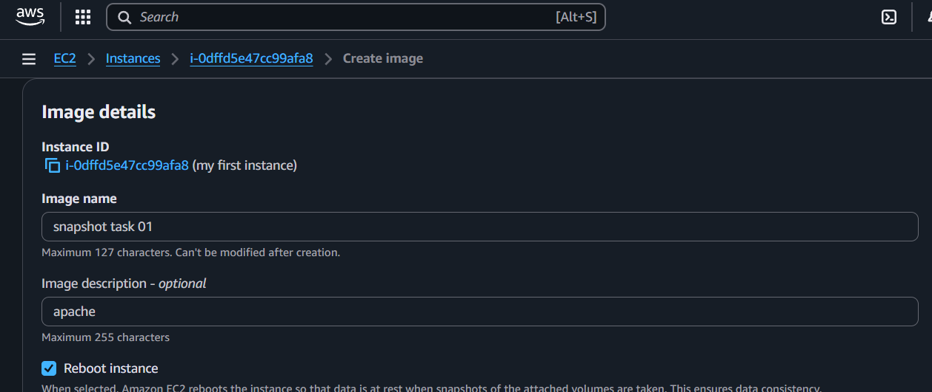
Step 5: select the option create image
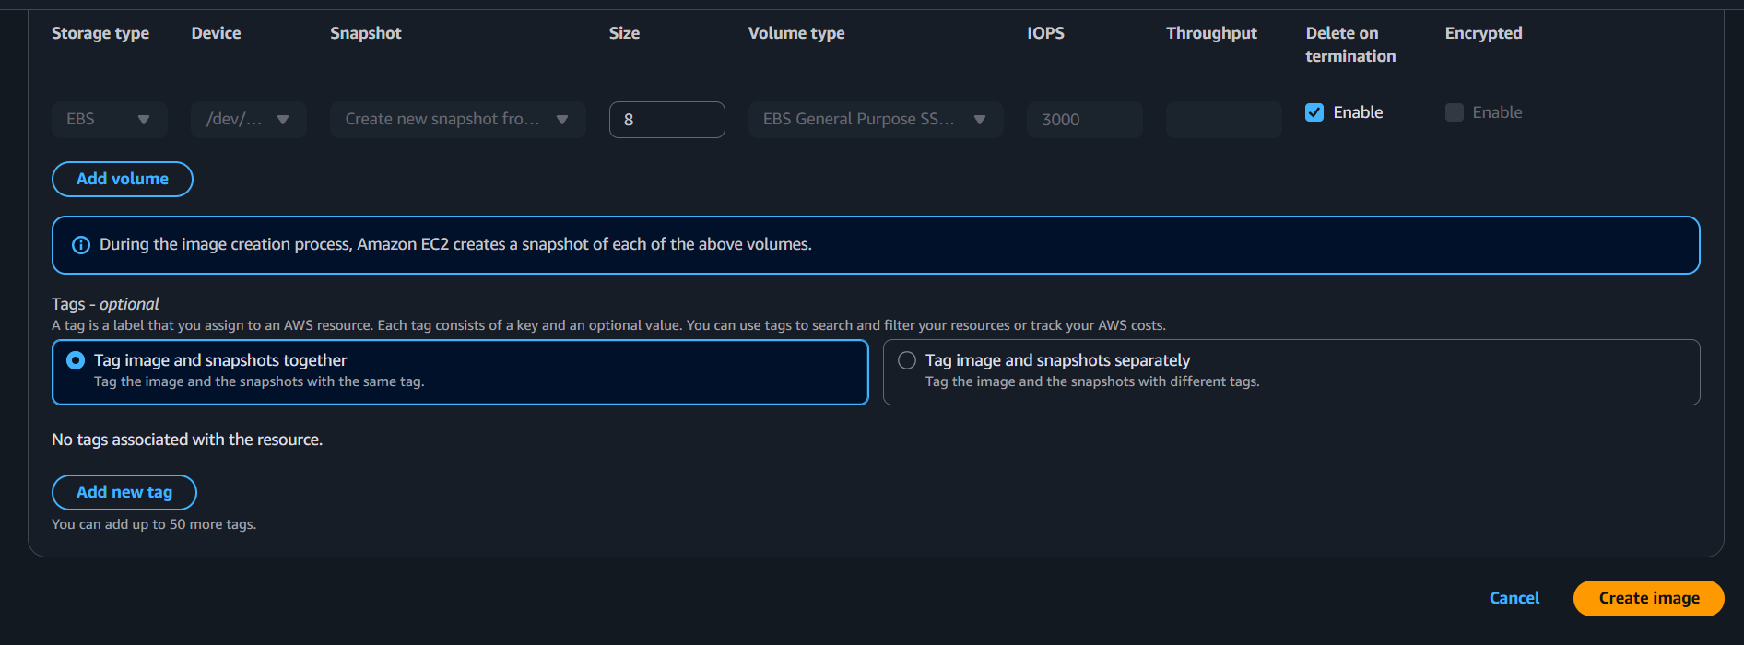
Step 6: your sanpshot has been created
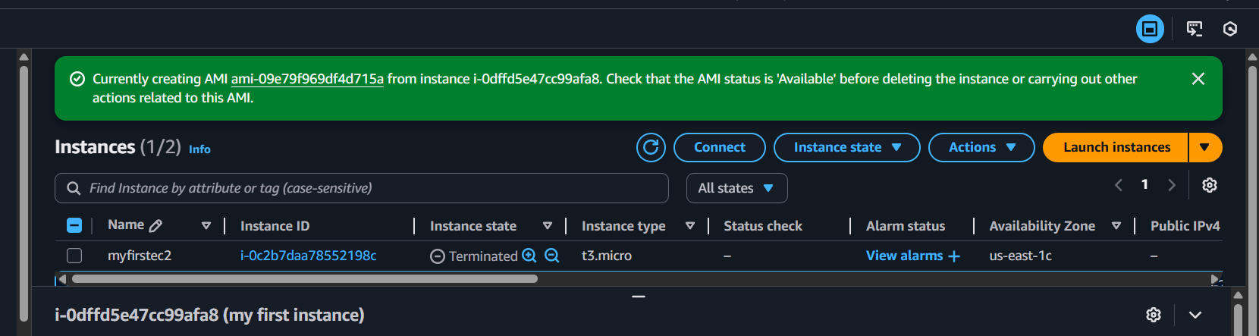
Step 7: if required then you can launch instance from AMI
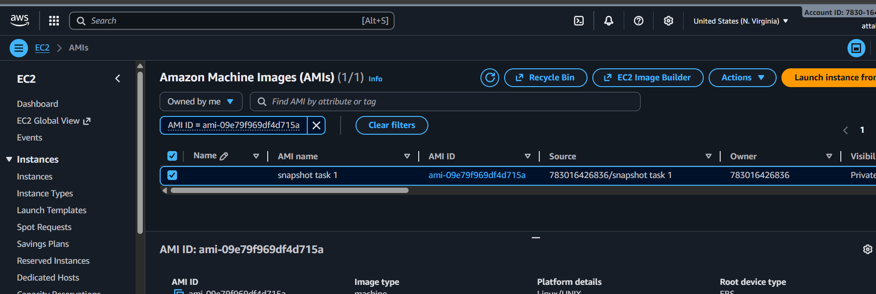

Launch one EC2 using Ubuntu image and add a script in user data to install Nginx.
Step 1: select launch instance option and select ubuntu image as AMI
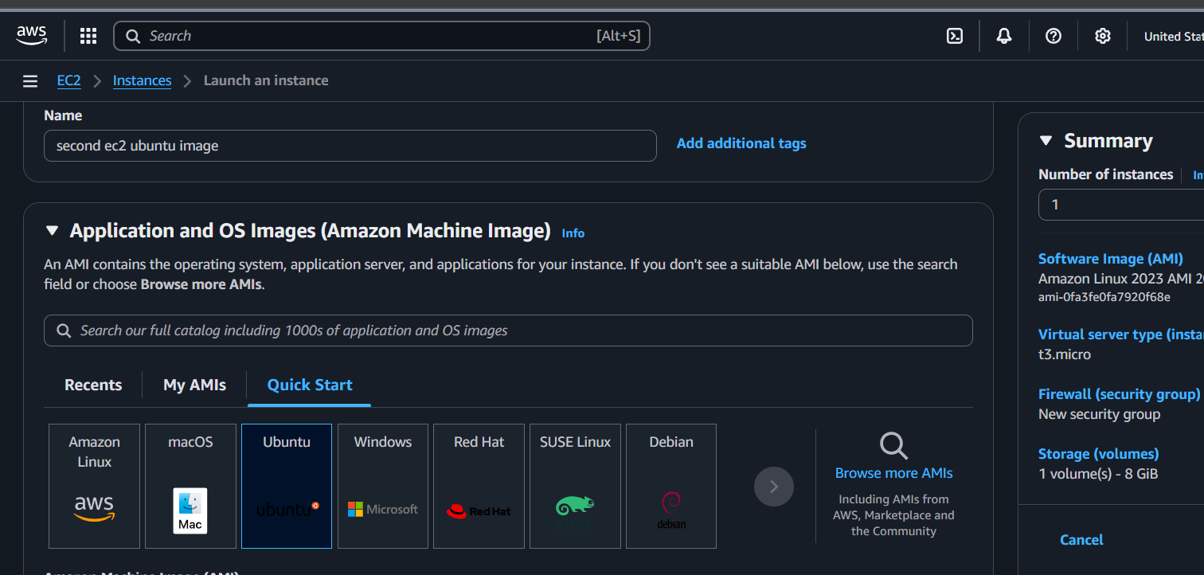
Step 2: select existing key pair or create new security key
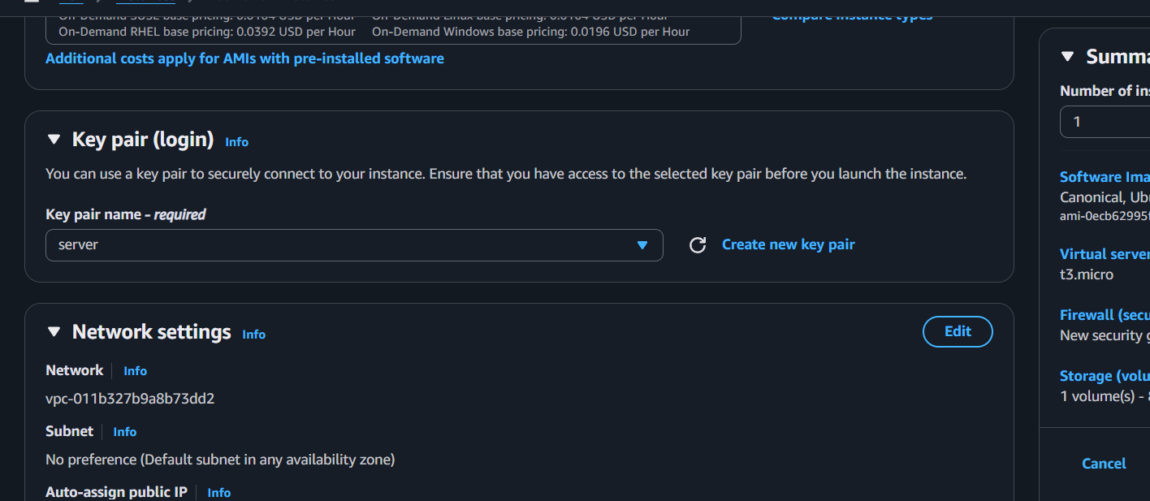
Step 3: select firewall security groups like default
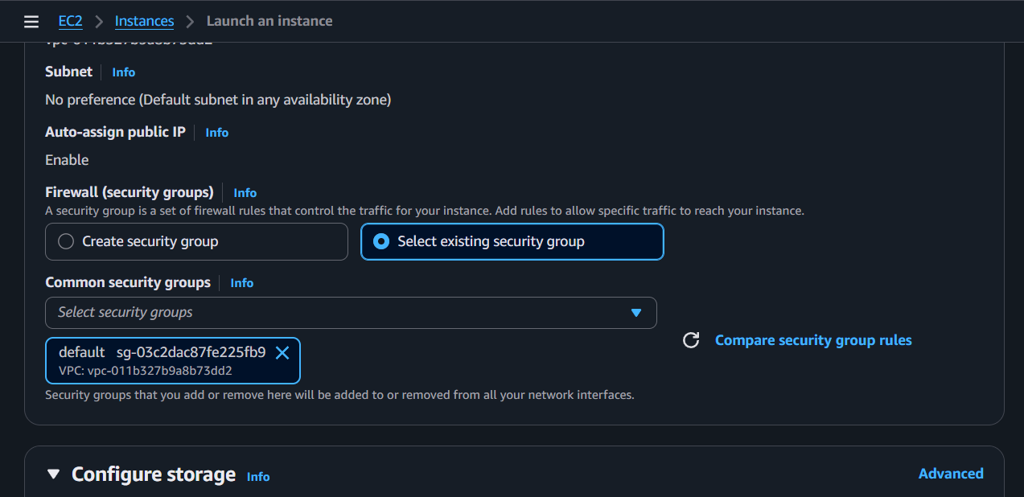
Step 4: in advanced options add bash script in userdata to install nginx
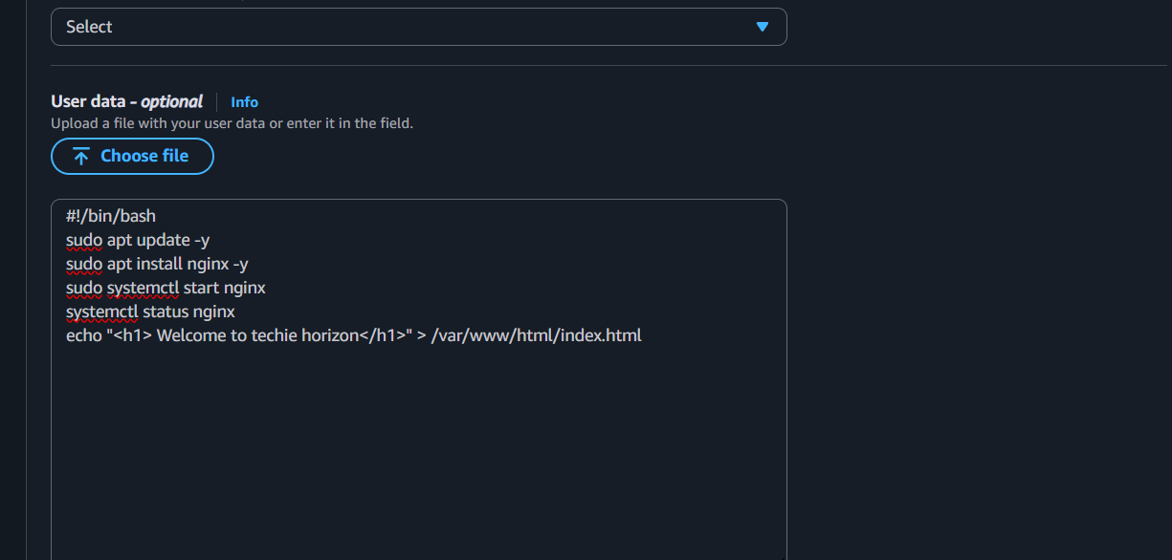
Step 5: then select launch instance to launch
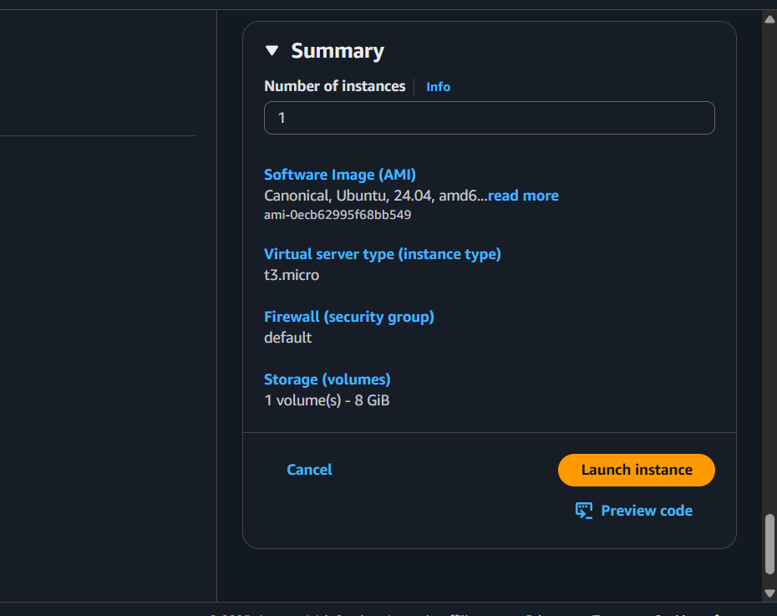

Your instance Is launched and click on the instance to know more details
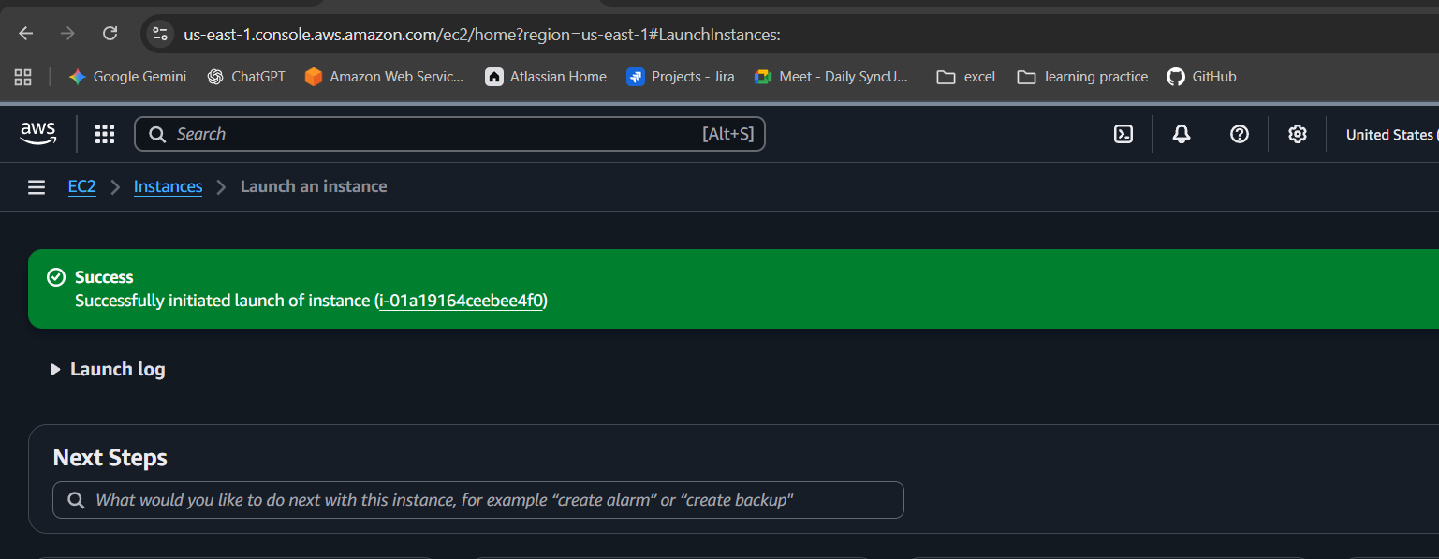
Step 6: click on connect option to connect with gitbash
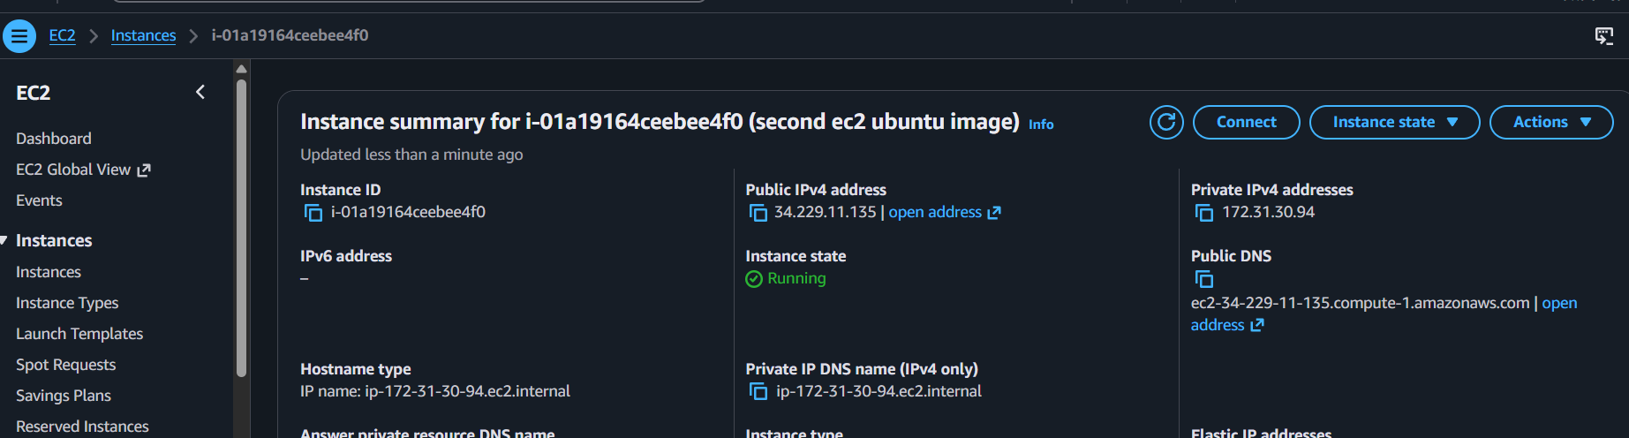
Step 7: copy secure from ssh client and paste it on your git bash
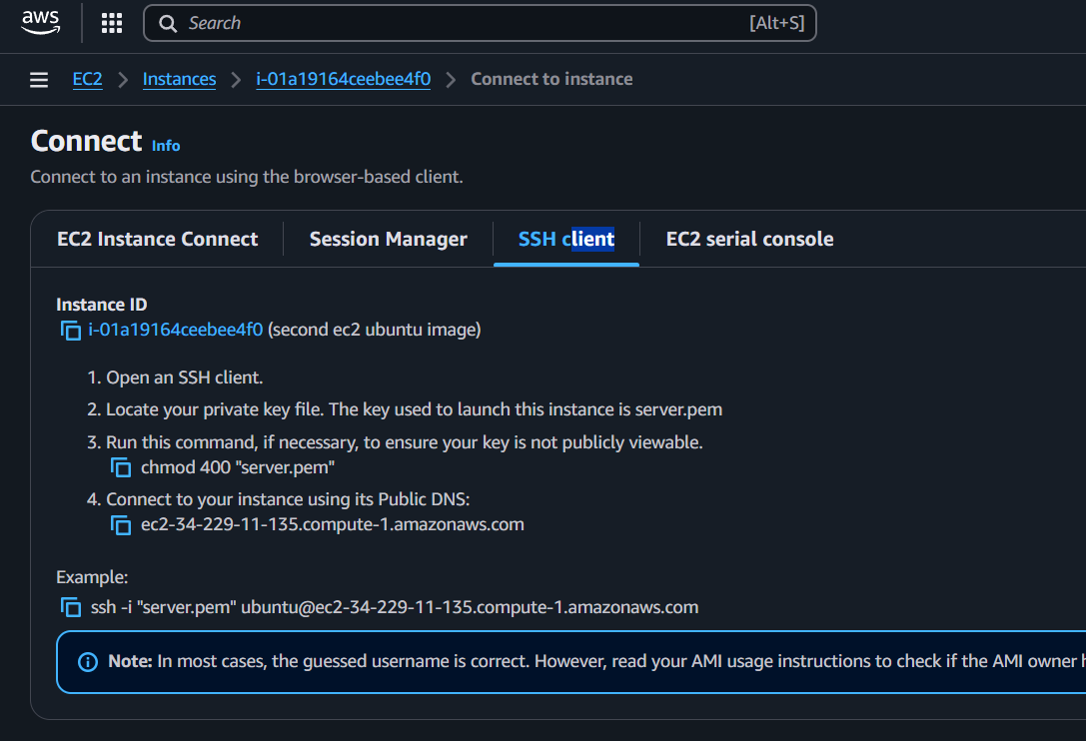
Step 8: open git bash from downloads or change directory to where your pem key is located then paste the ssh link
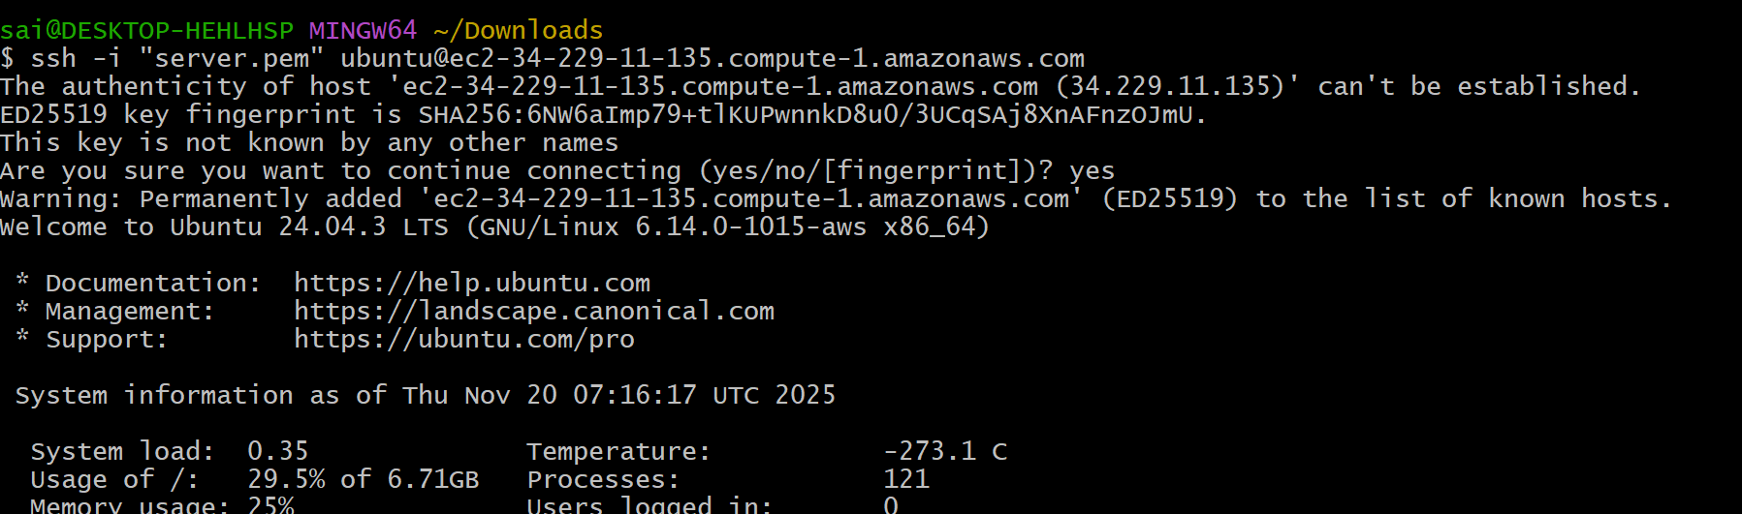
Step 9: checking the output using cat command
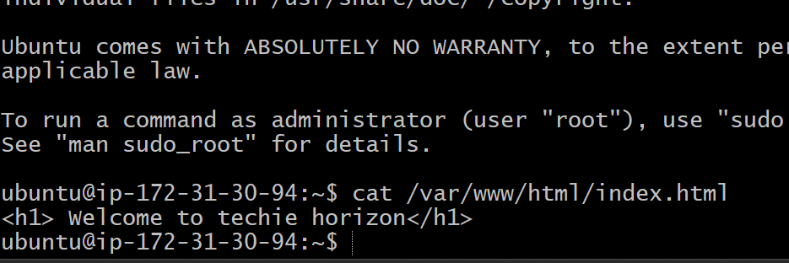
Step 10: verifying in web portal
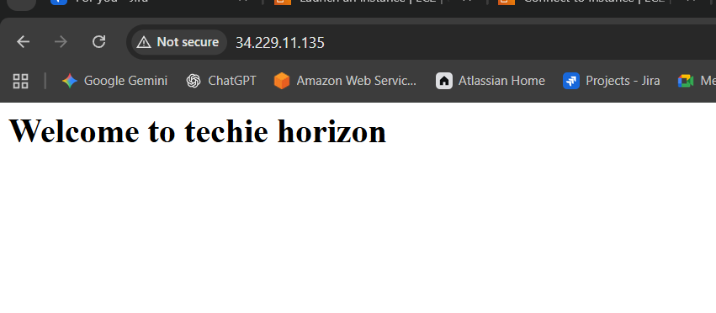

Enable termination policy on the EC2 created in Task 2.
STEP 1: Open actions tab to acces instance settings
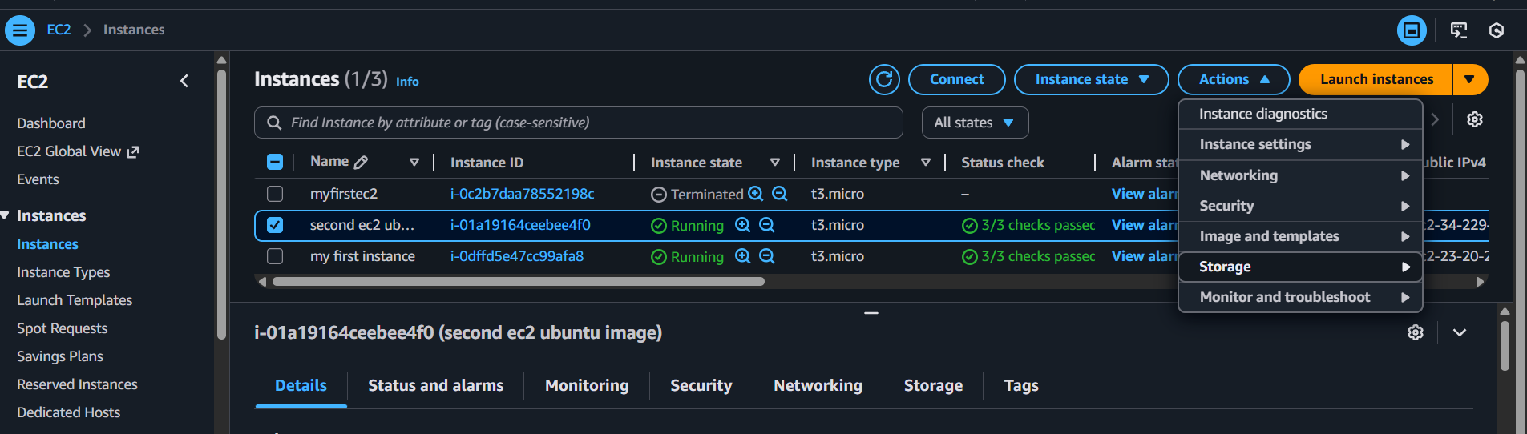
Step 2: then select change termination protection option
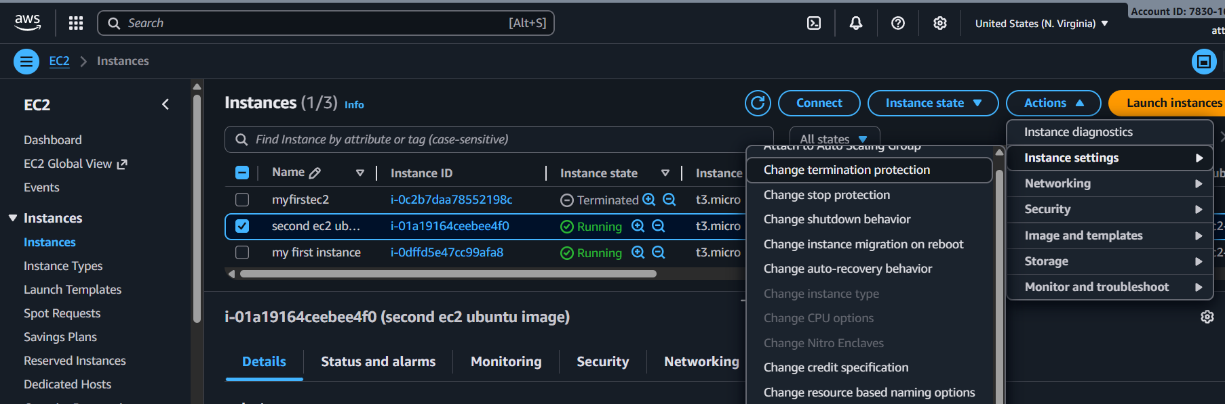
Step 3: enable the termination protection option and save
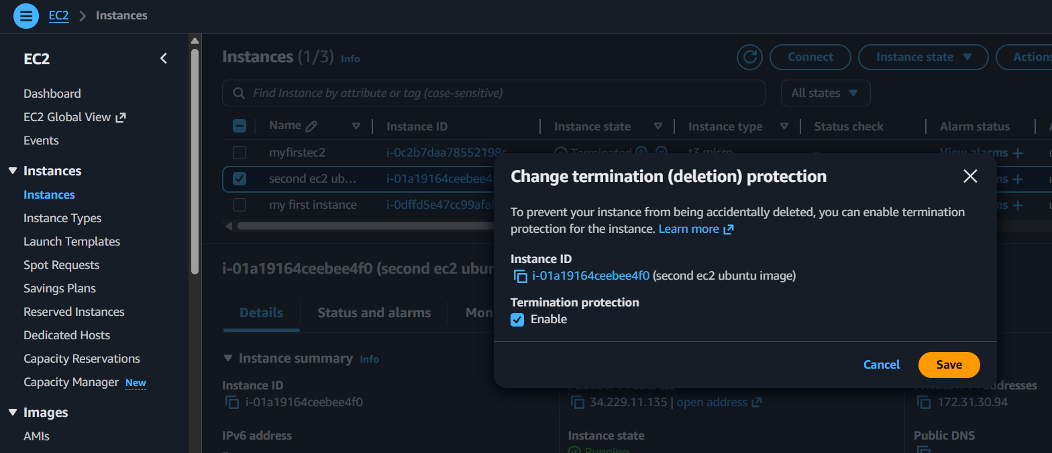
Step4 : here is the output
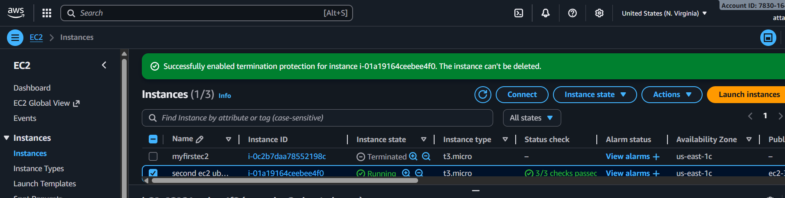

Launch one Windows server and install Tomcat on Windows
Step 1: launch instance as regular but select windows as os image and launch instance
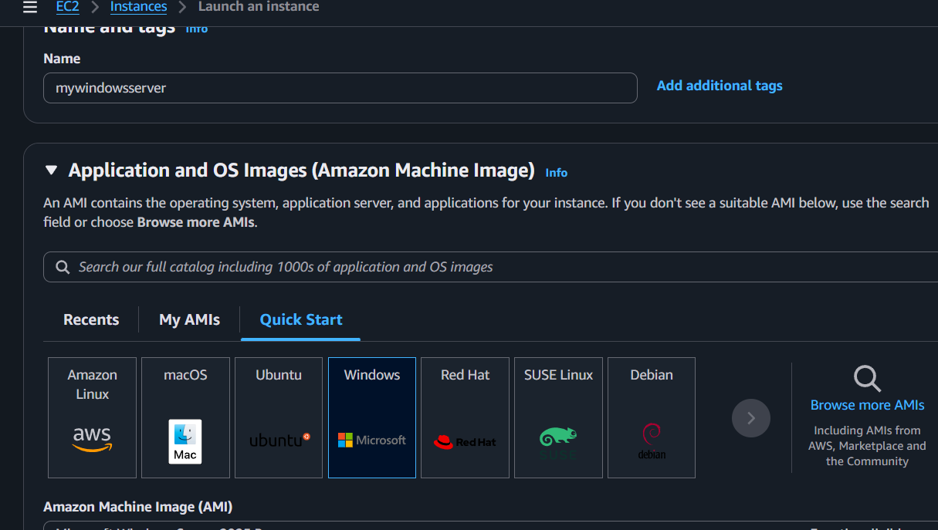
Step 2: select the option connect then select RDP client to access
Step 3: set the password by uploading pem key to decrypt and it gives a new password
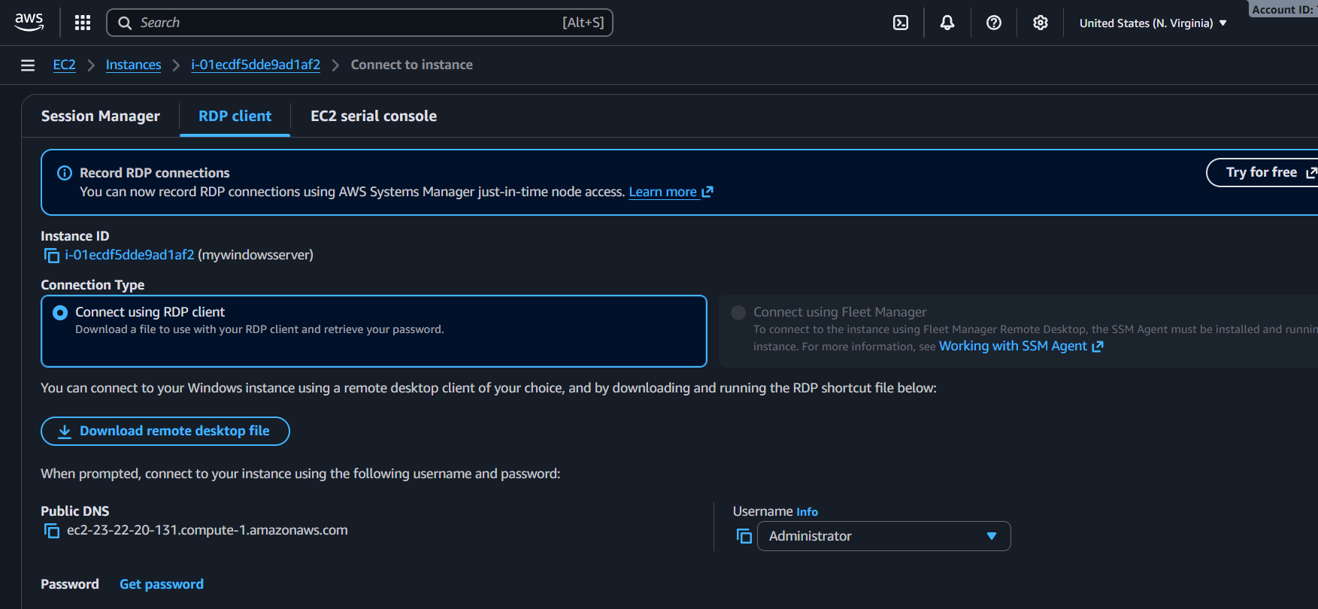
Step 4: download the remote desktop file
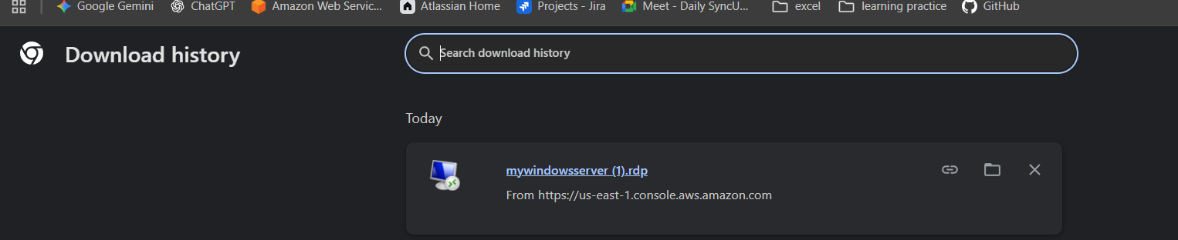
Step 5: run the application which is been downloaded and provide the password which you got from ec2
Step 6 : then you wil be redirected to windows server which is same to our OS

Step 7 : go to browser and download the java version and apache tomcat application
Step 8: install java and then install apache tomcat
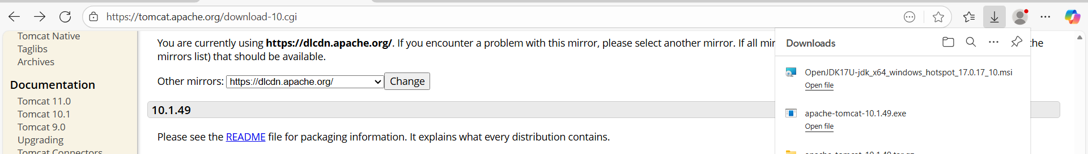
Select the java path if needed
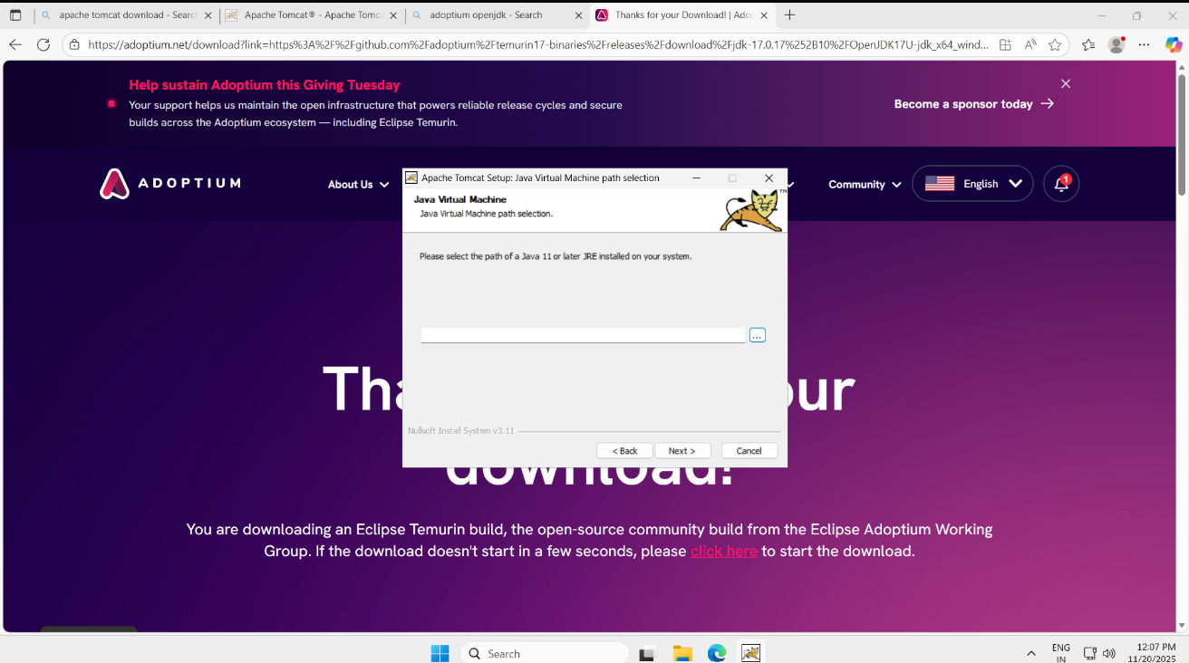
Step 9: verify in webserver by entering localhost:8080 for tomcat image
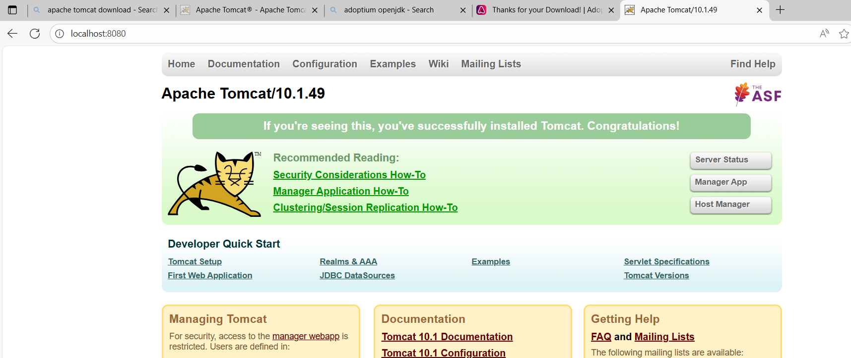

Launch any EC2 using the spot purchasing option.
Do the Same process as regular ec2 instance
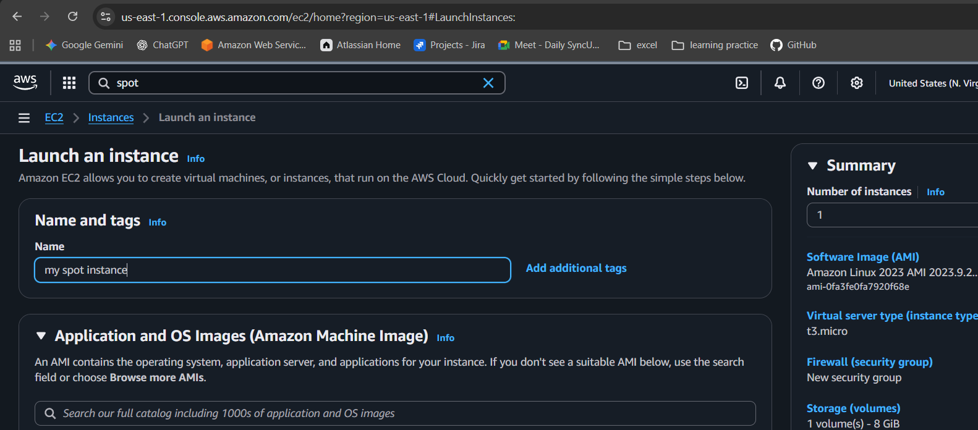
Open advanced options to select spot instances option
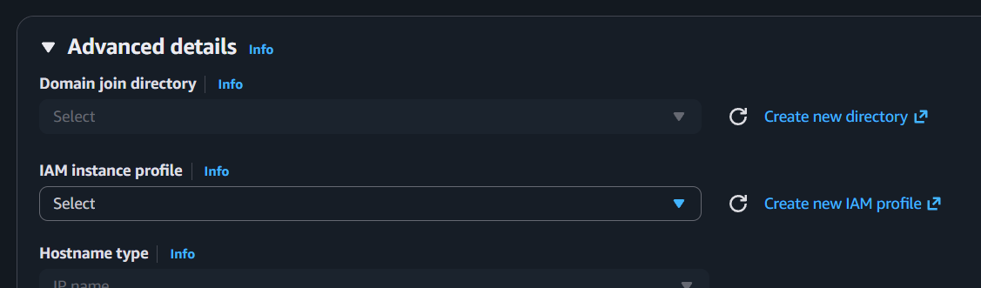
Select as per your requirement
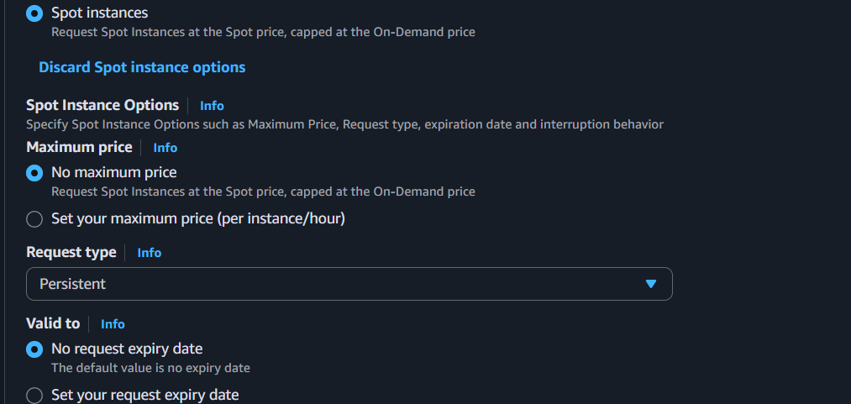

Instance got created
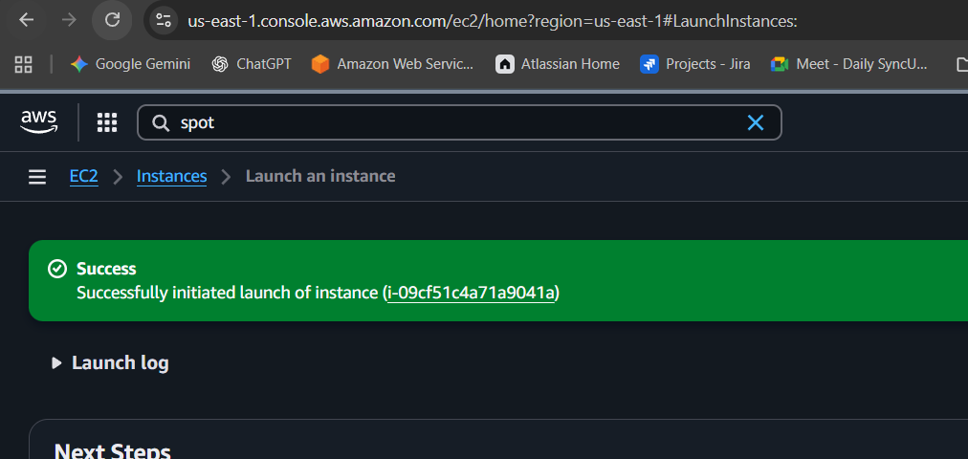
Verified in list of instances
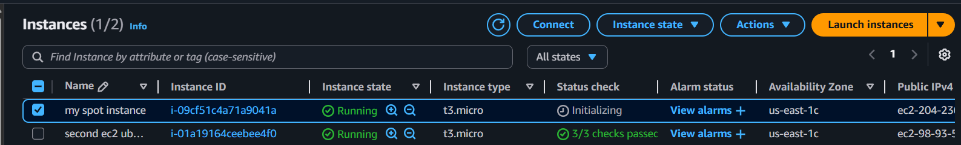

Assign passwordless authentication for the EC2 created in Task 2.
Step 1: generate ssh-keygen and copy the public key
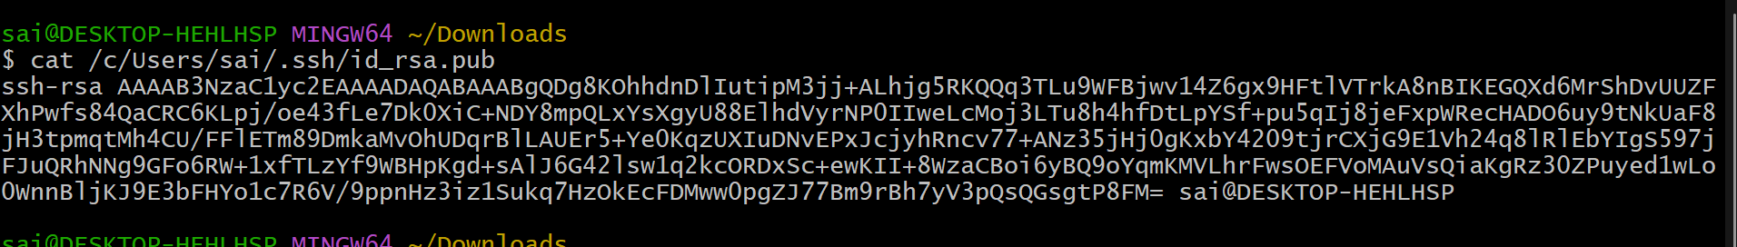
Step 2: launch the ec2 instance and connect to ec2 instance
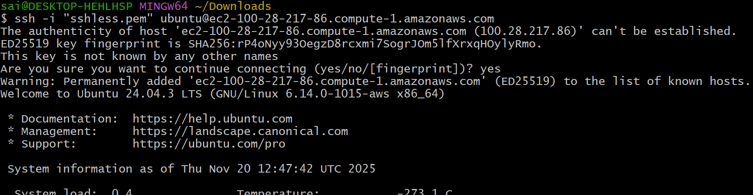
Step 3: change the directory to .ssh/ and access authorize keys using vi
And insert the public into it and exit from ec2
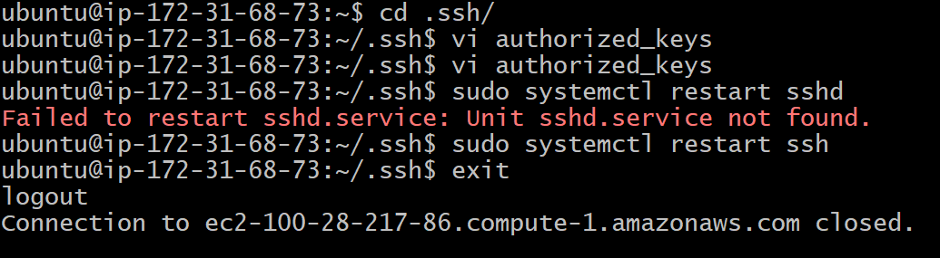
Step 4: login again without using pem key
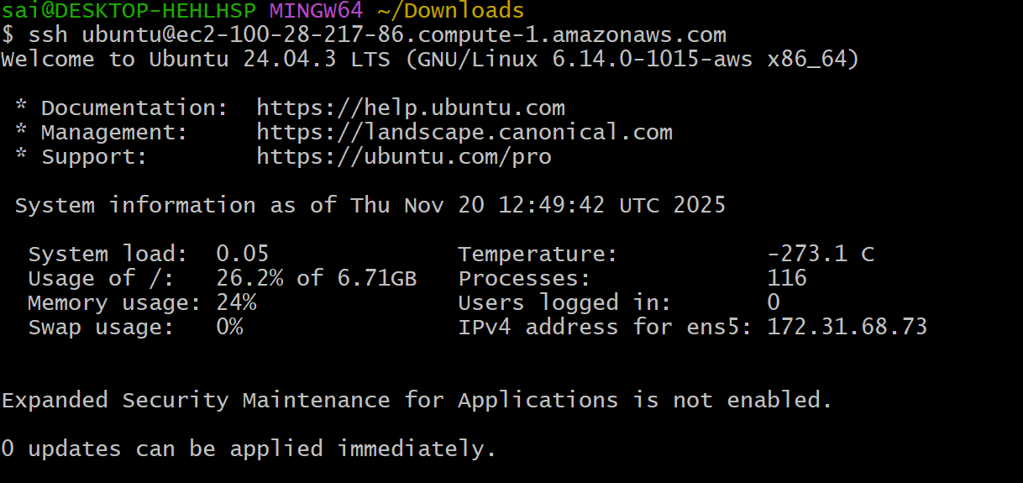

Launch one EC2 using AWS CLI.
Go to user and create a user with all details shown in below outputs
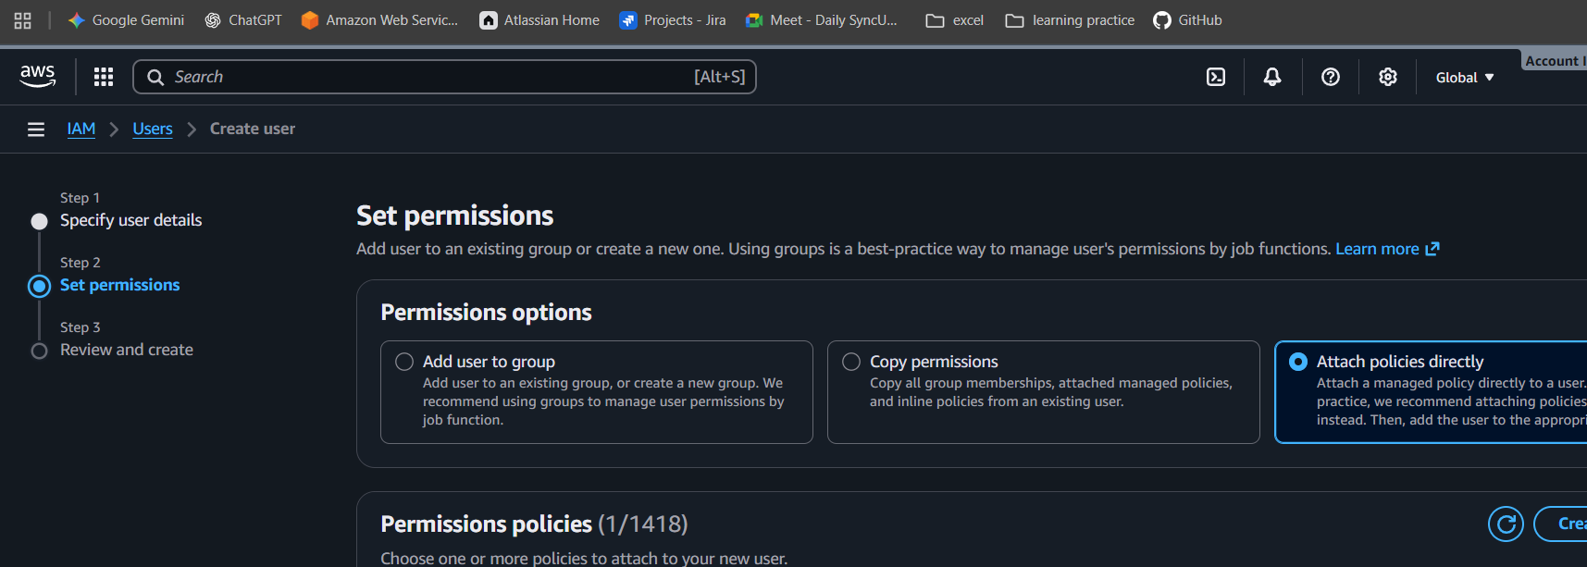
select amazonec2full access
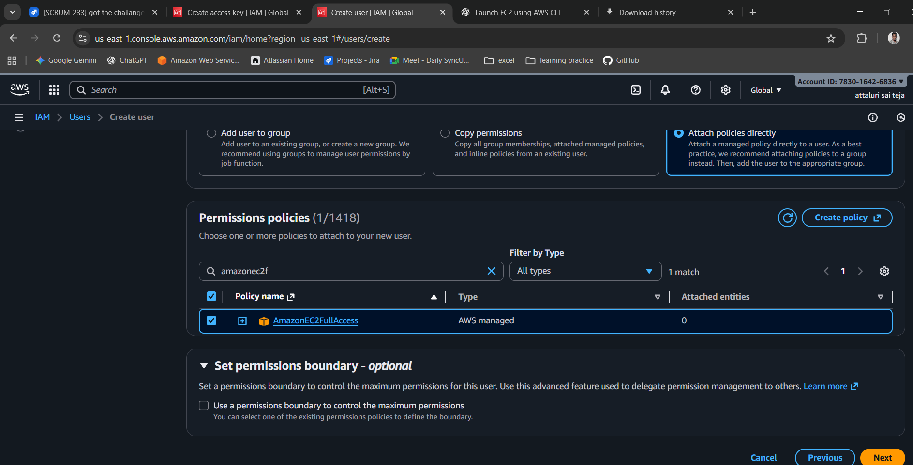
then create the user and click on user
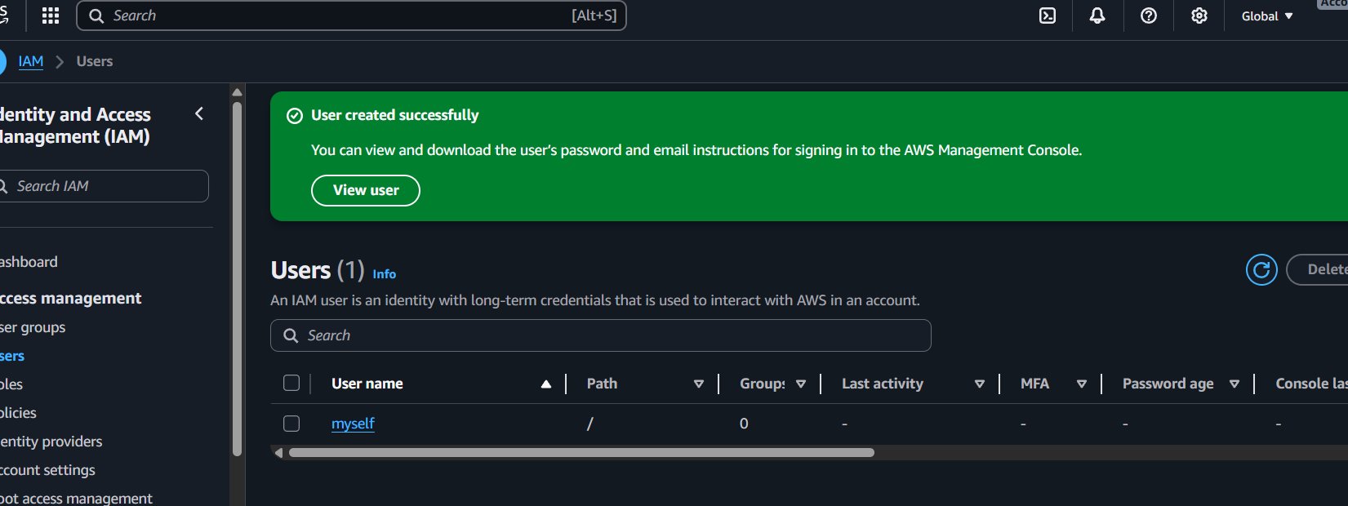

Then create an access key
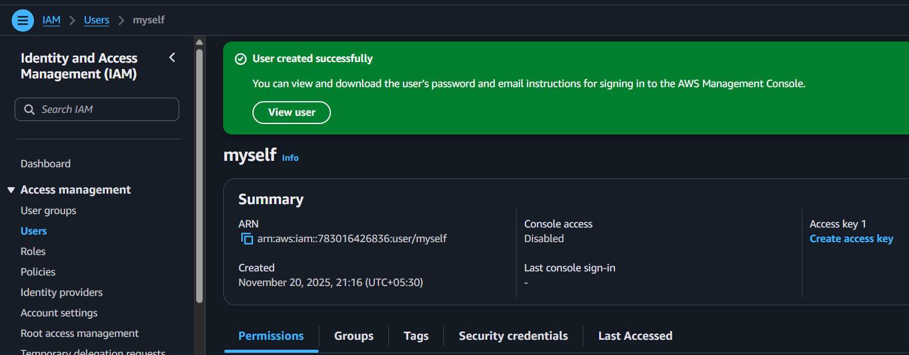
Then select command line interface
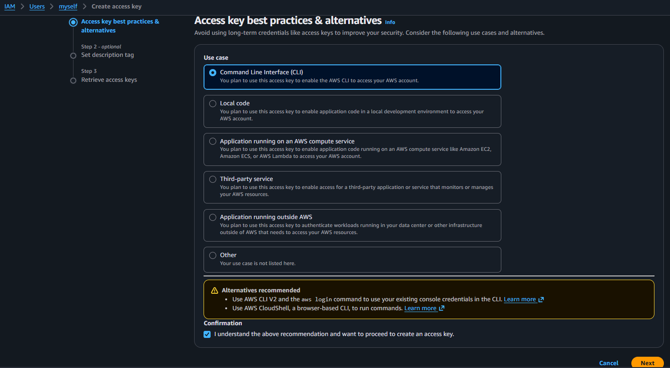

Then create a access key and download it don’t close the page we need to copy id and password
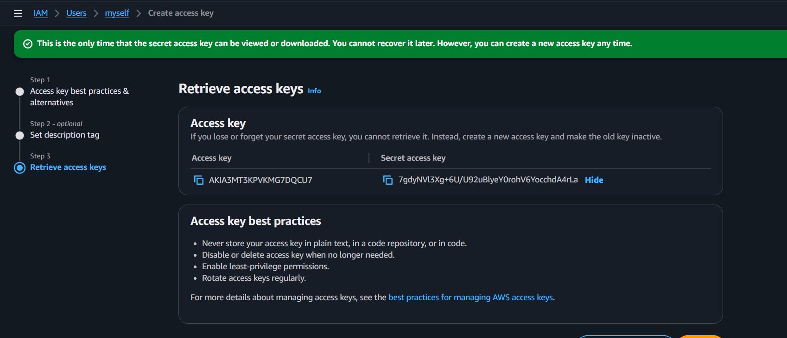
Then install amazon cliv2.msi use the below link to download and install it
https://awscli.amazonaws.com/AWSCLIV2.msi
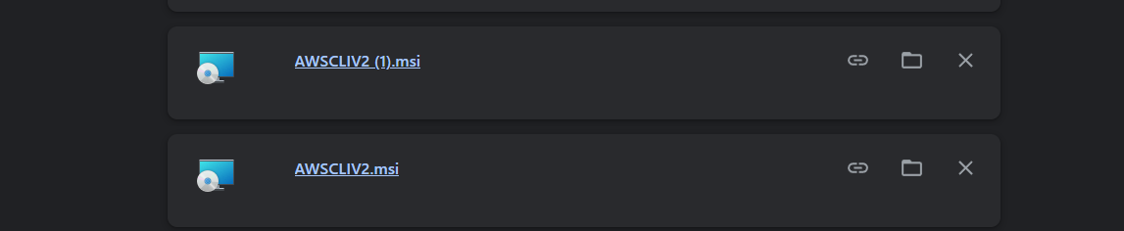
After the installation check aw—version in git bash
Then configure aws by command aws configure
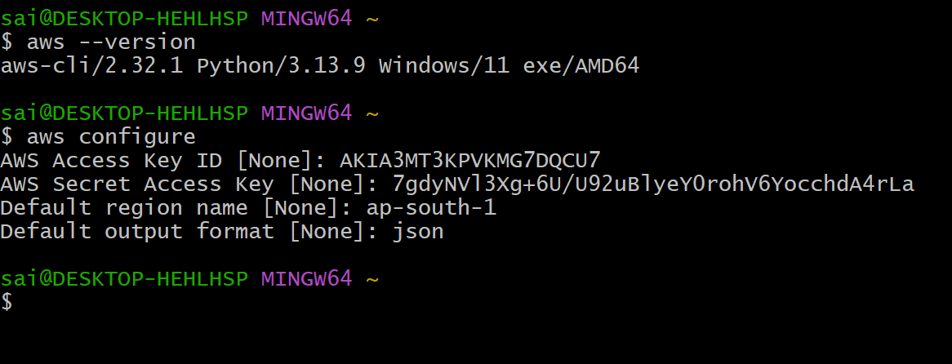

Run the first command from below mentioned last of this task
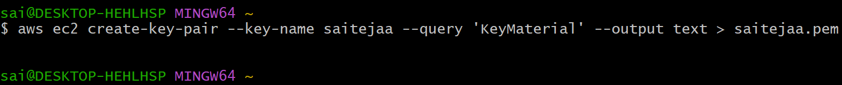
After successfully execution verify in aws account in key pairs section
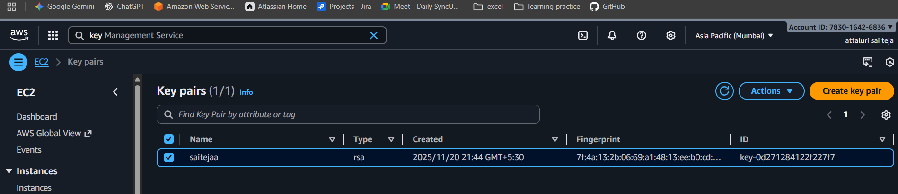
Then execute security groups commands and port number
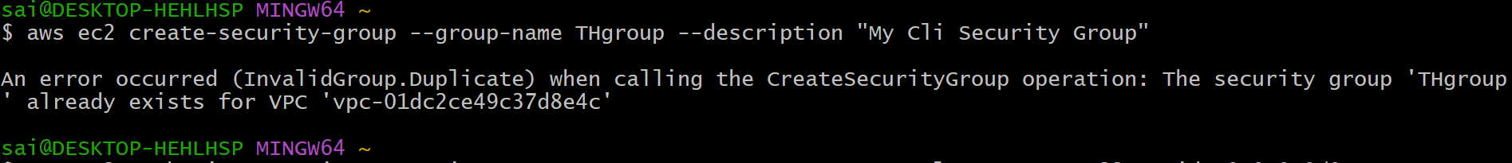
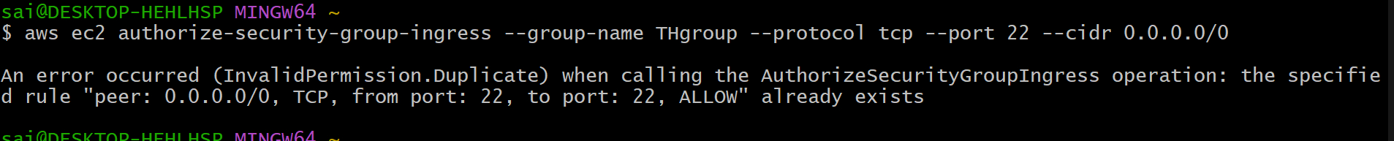
Then also verify in aws using security groups
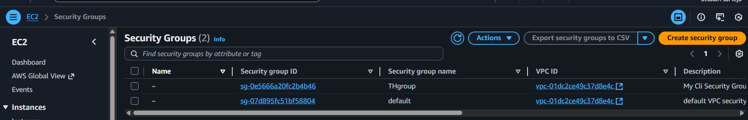

Then run the last command to launch the instance
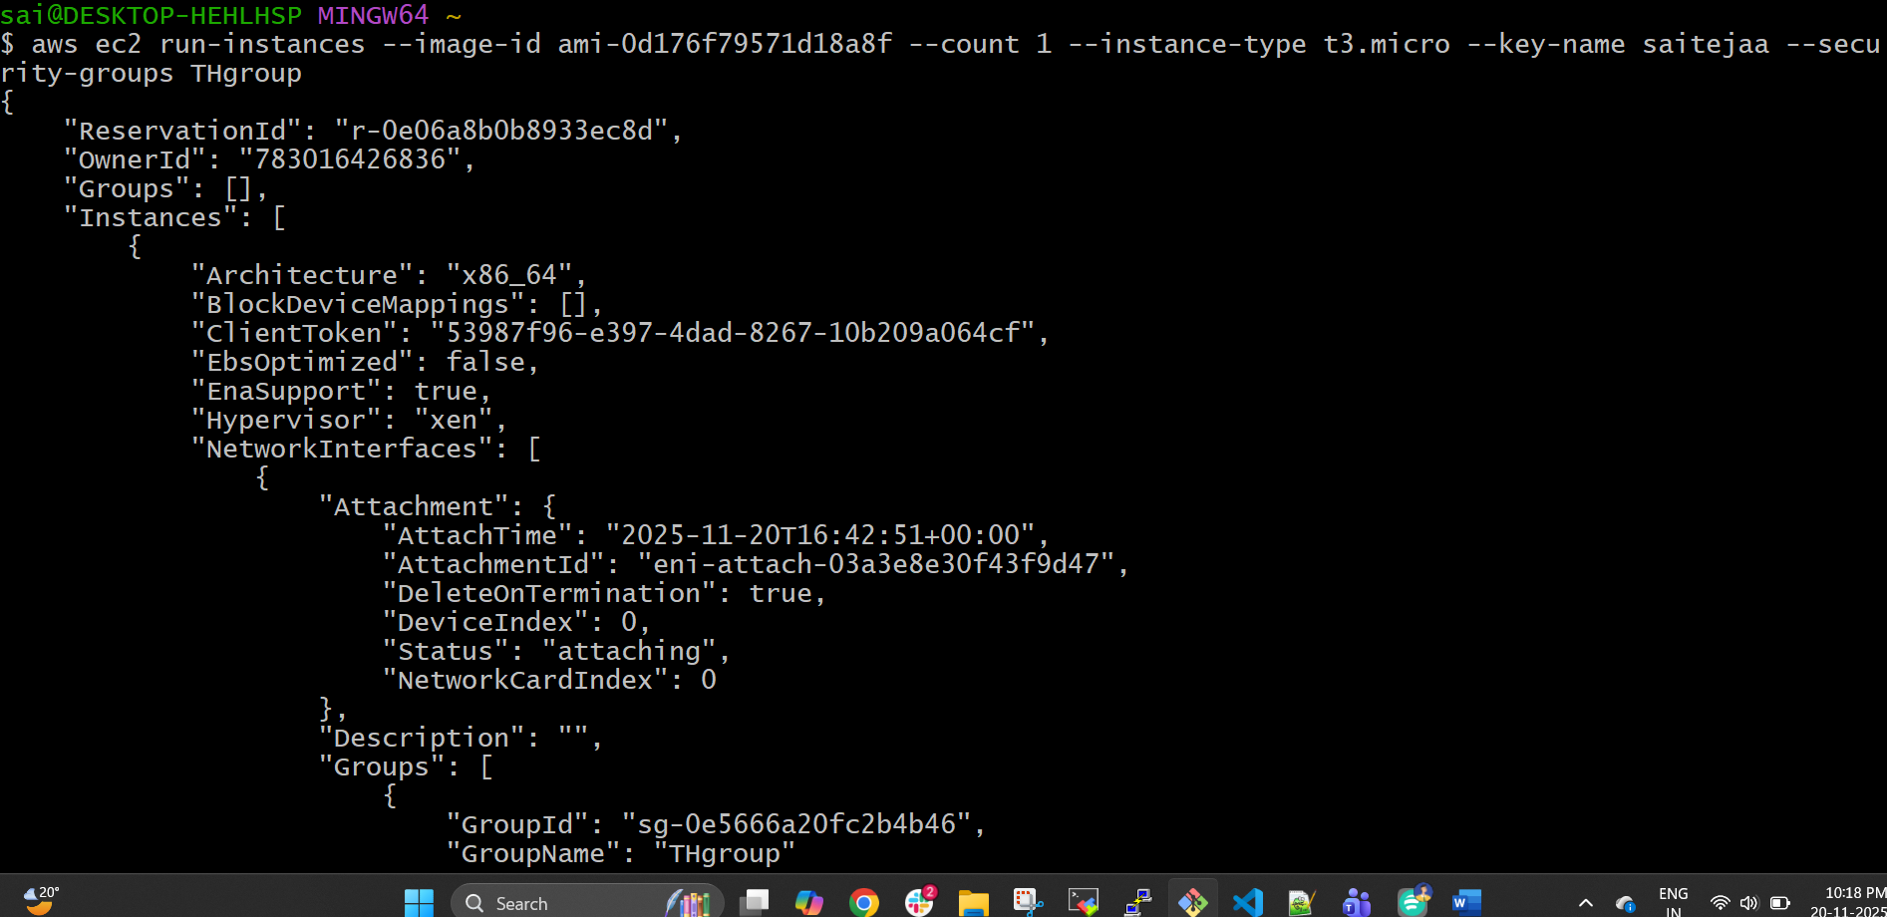
Then verify the instance in instrances section
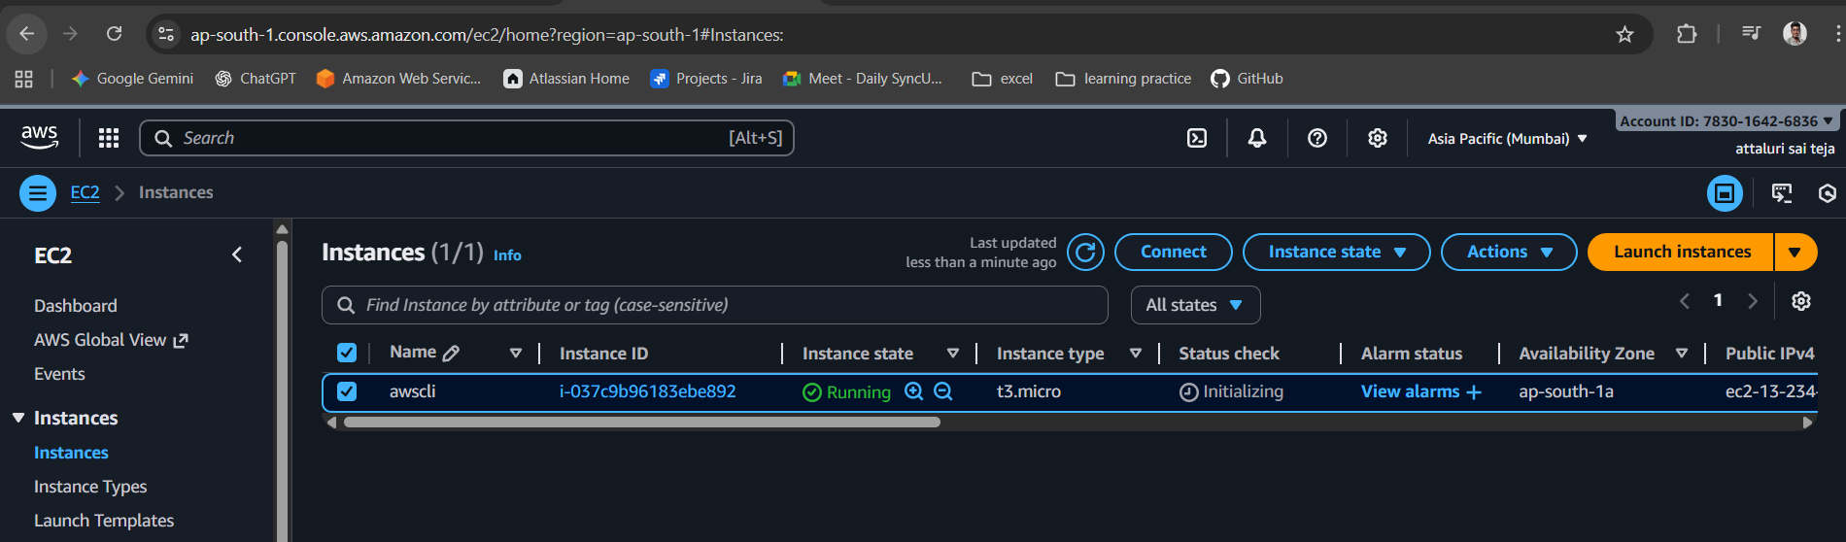
Then give the name for instance
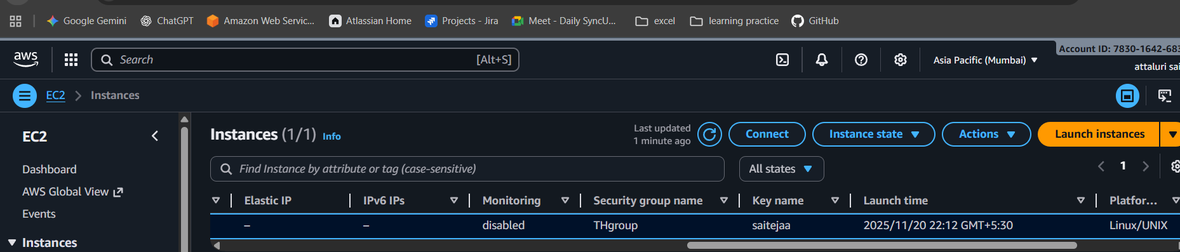

NOTE: the region should be same as you mentioned in Default region in second command while configuring aws

Commands (modify details as of your requirement)
aws ec2 create-key-pair --key-name saitejaa --query 'KeyMaterial' --output text > saitejaa.pem
aws ec2 create-security-group --group-name THgroup --description "My Cli Security Group"
aws ec2 authorize-security-group-ingress --group-name THgroup --protocol tcp --port 22 --cidr 0.0.0.0/0
aws ec2 run-instances --image-id ami-0d176f79571d18a8f --count 1 --instance-type t3.micro --key-name saitejaa --security-groups THgroup

